**JOINS:**

**Creating database:**

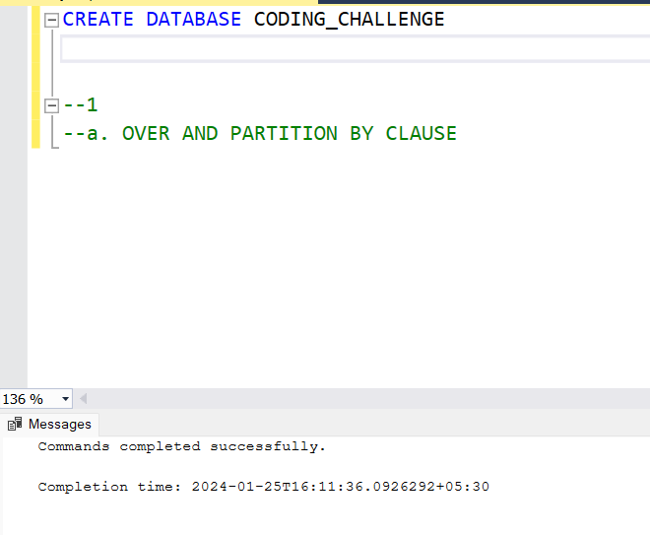

**We used two tables to perform the operations.**

**Creation of table 1 : Department**

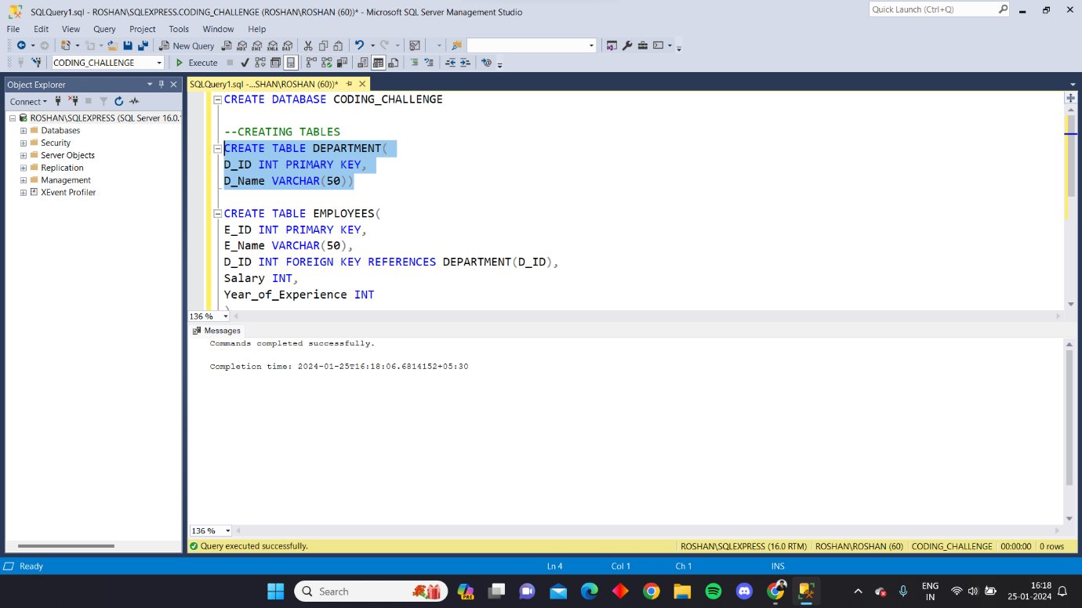

**Creation of table 2: Employees**

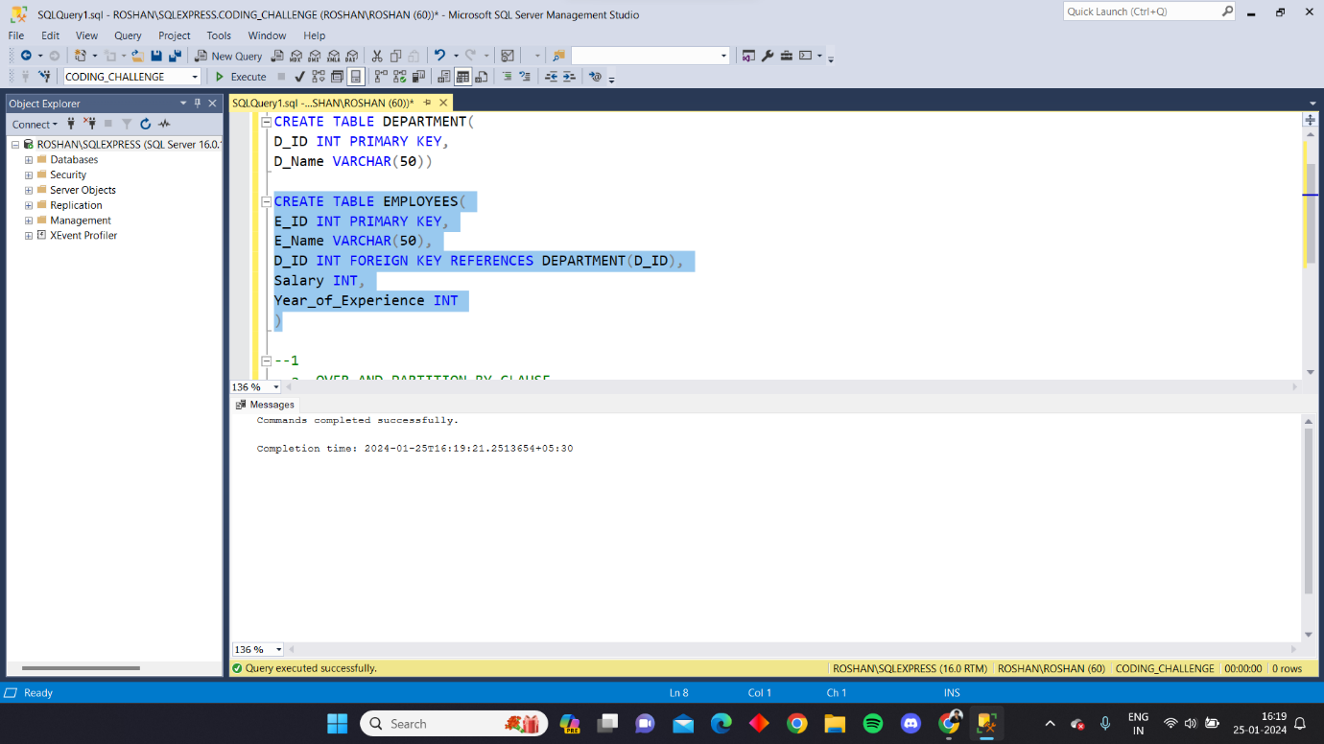

**Inserting data in department:**

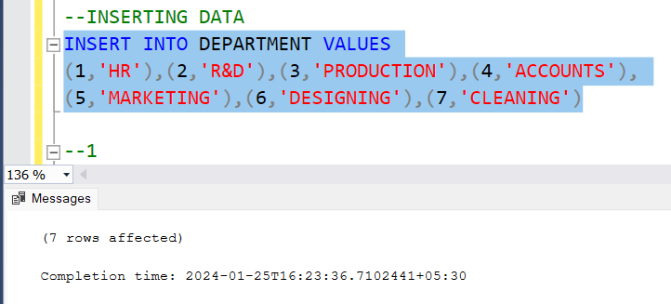

**Inserting data in employees:**

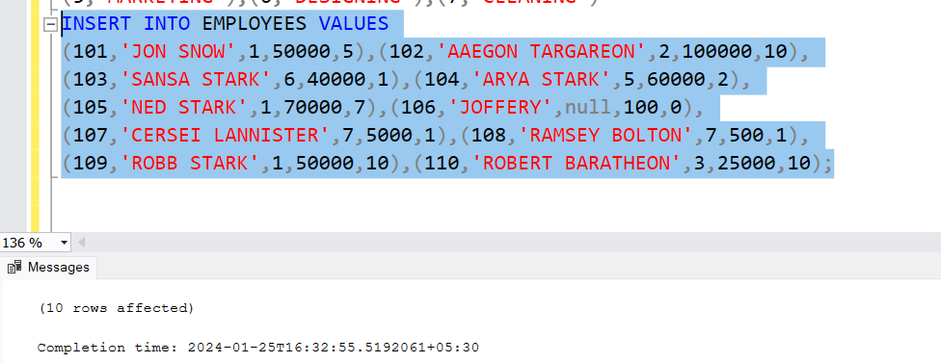

1. **Natural Join: It joins the tables and gives the common data**

**Query:**

SELECT * FROM EMPLOYEES AS E

JOIN DEPARTMENT AS D ON D.D_ID=E.D_ID

**OUTPUT:**

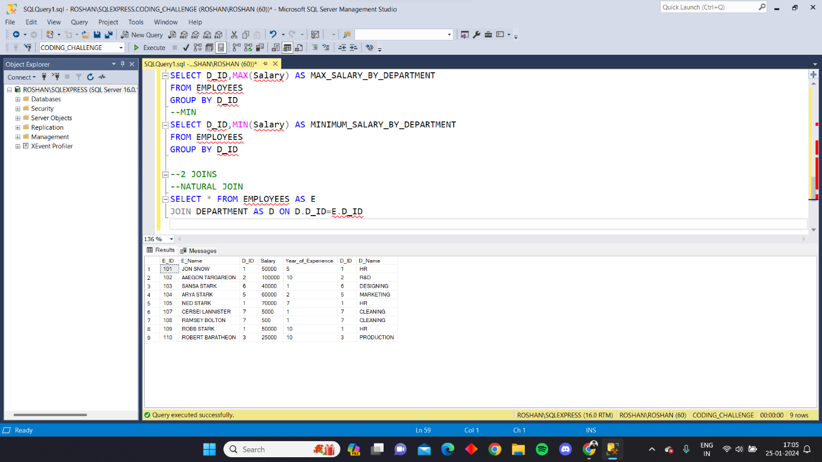

1. **Inner join: It joins the tables and gives the common data**

**QUERY:**

SELECT * FROM EMPLOYEES AS E

INNER JOIN DEPARTMENT AS D ON E.D_ID=D.D_ID

**OUTPUT:**

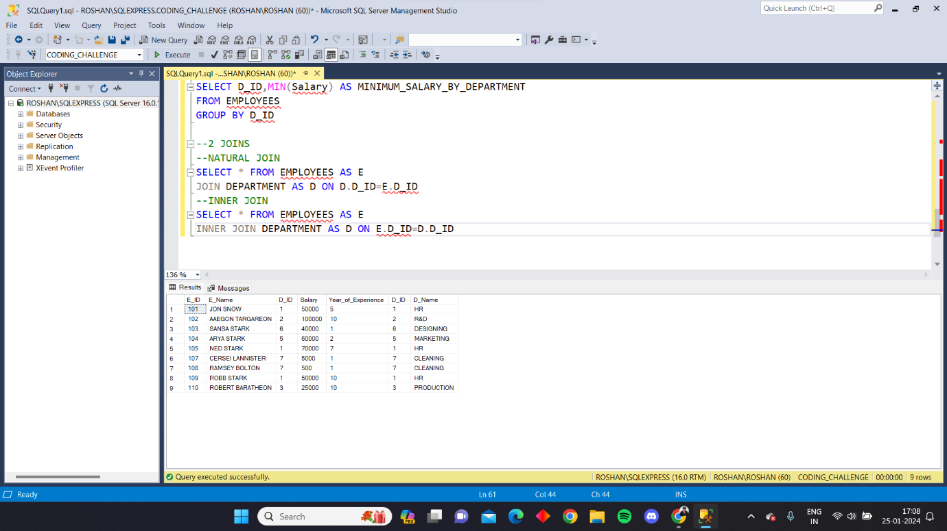

1. **Left join: It joins the tables and gives the common data along with the left or first table data**

**QUERY:**

SELECT * FROM EMPLOYEES AS E

LEFT JOIN DEPARTMENT AS D ON E.D_ID=D.D_ID

**OUTPUT:**

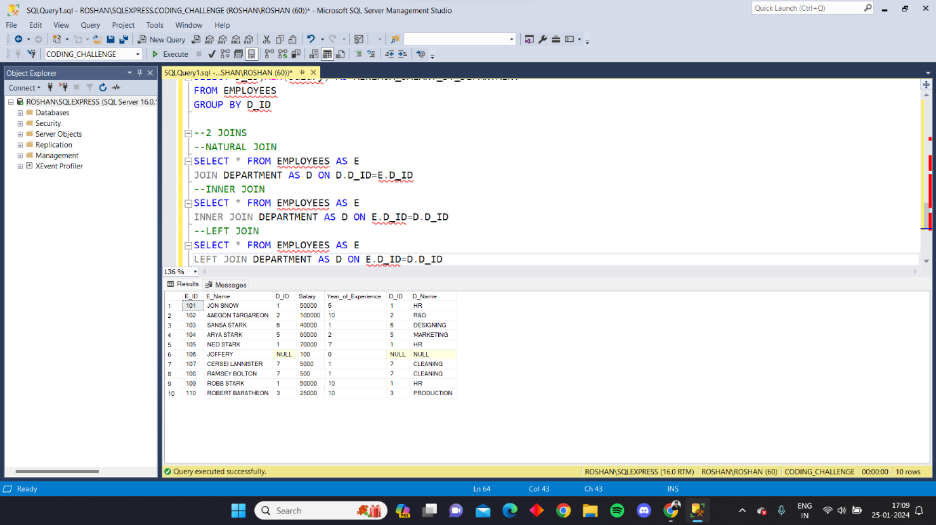

1. **Right join:It joins the tables and gives the common data along with the right or second table data**

**QUERY:**

SELECT * FROM EMPLOYEES AS E

RIGHT JOIN DEPARTMENT AS D ON E.D_ID=D.D_ID

**OUTPUT:**

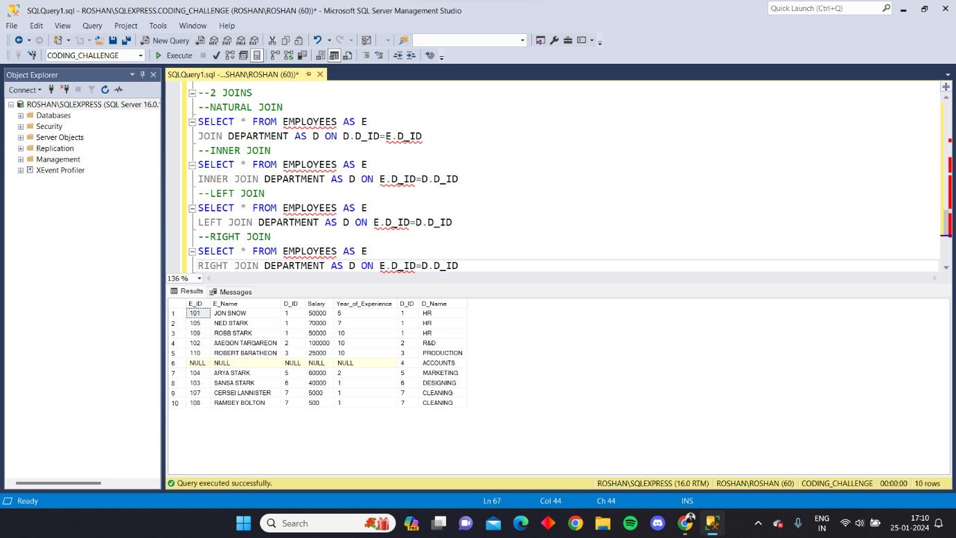

1. **Full outer join: It gives all the data**

**QUERY:**

SELECT * FROM EMPLOYEES AS E

FULL OUTER JOIN DEPARTMENT AS D ON E.D_ID=D.D_ID

**OUTPUT:**

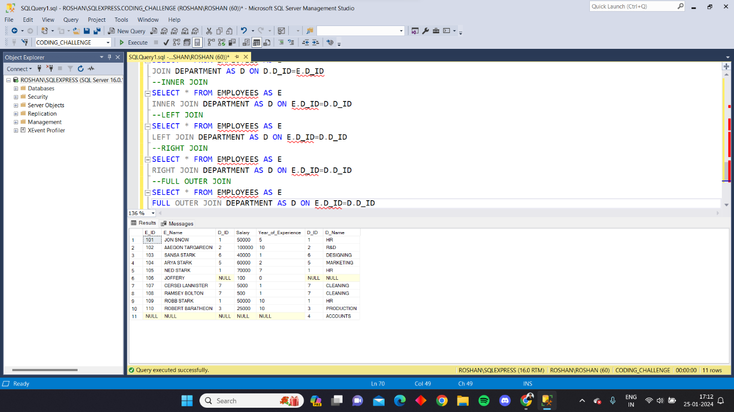

1. **Cross join:**

**QUERY:**

SELECT * FROM EMPLOYEES

CROSS JOIN DEPARTMENT

**OUTPUT:**

